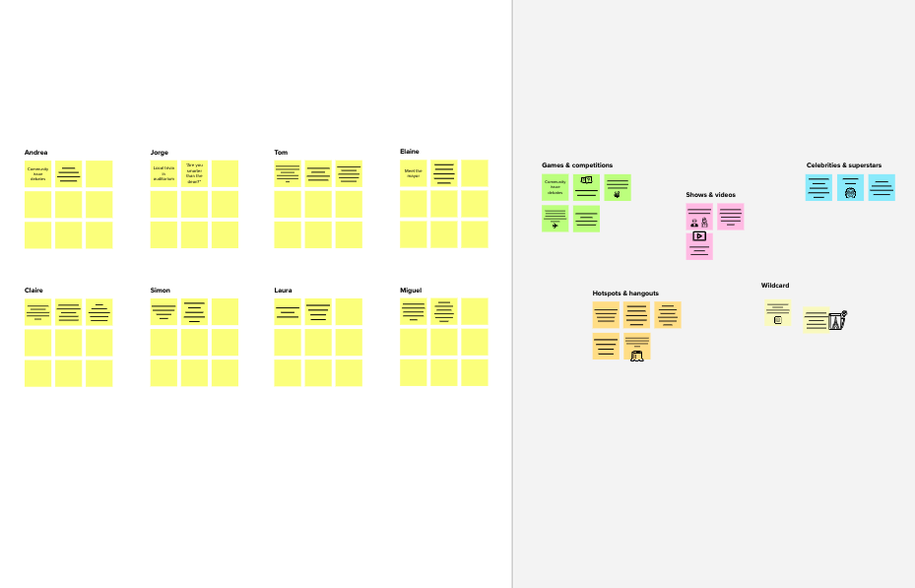

Brainstorm

& idea prioritization

## Before you collaborate

### A little bit of preparation goes a long way with this session. Here’s what you need to do to get going.

#### 10 minutes

**A Team gathering**

Define who should participate in the session and send an

**1**

## Define your problem statement

### What problem are you trying to solve? Frame your problem as a How Might We statement. This will be the focus of your brainstorm.

#### 5 minutes

**2**

## Brainstorm

### Write down any ideas that come to mind that address your problem statement.

#### 10 minutes

##### Nandhitha S

Collecting

**Parallel supply in different locations**

**TIP**

You can select a sticky note and hit the pencil [switch to sketch] icon to start drawing!

**Priyadharshini E**

Identify new opportunity and to correct devization.

seasonality

Vertically supply chain

## 3

**Group ideas**

### Take turns sharing your ideas while clustering similar or related notes as you go. In the last 10 minutes, give each cluster a sentence-like label. If a cluster is bigger than six sticky notes, try and see if you and break it up into smaller sub-groups.

#### 20 minutes

**TIP**

## 4

**Prioritize**

### Your team should all be on the same page about what's important moving forward. Place your ideas on this grid to determine which ideas are important and which are feasible.

**20 minutes**

## After you collaborate

You can export the mural as an image or pdf to share with members of your company who might find it helpful.

## Quick add-ons

**A Share the mural**

Use this template in your own brainstorming sessions so your team can unleash their imagination and start shaping concepts even if you're not sitting in the same room.

invite. Share relevant information or pre-work ahead.

1. **Set the goal**

Think about the problem you'll be focusing on solving in the brainstorming session.

##### Learn how to use the facilitation tools

Use the Facilitation Superpowers to run a happy and

productive session.

data from food industry

food expiere

date

Optimize the losses

large number of products price, quality and manufacture date

Bring in all the past records related to food forecast.

**Give accuracy for problems compare with other**

**make informed decision**

Predictive and analysis

Non linearity in data pattern

Predict approach demand relation

Reduction of idle stock

Data

USER DATA COLLECTION

Collecting data from industries

Collect data from previous patternl

Collect data on the food banks

DEVELOPMENT PROCESS

# 

Checking of previous data

identify demand depend on food

Improve Methods

Add customizable tags to sticky notes to make it easier to find, browse, organize, and categorize important ideas as themes within your mural.

Collecting data from industries

Keep the contact details of food pattern

**Share a view link** to the mural with stakeholders to keep them in the loop about the outcomes of the session.

**B Export the mural**

Export a copy of the mural as a PNG or PDF to attach to emails, include in slides, or save in your drive.

**10 minutes** to prepare

**1 hour** to collaborate

**2-8 people** recommended

[**Open article**](https://support.mural.co/en/articles/2113740-facilitation-superpowers)

**Key rules of brainstorming**

Sharing steps they can take to identify the forecast

To run an smooth and productive session

**Pavithra S**

|  |  |  |
| --- | --- | --- |
| Food content details | Food quality | Reduce historical disputes |
| Structuring and analytics | Provide information speed | Substitutev product losses. |

**Priyadharshini R**

**Improve planning for sakles, marketing fionance**

Higher customer satisfaction

Improve workforce planning

# 

Sense the actual order

Gather information from various portal

Identify the actual number bof sales for the coming mo nths a

Identify internal and external trends

Analyze every parameter that affects demand for product using advanced technology

Collect data on the industry

# 

Optimize the forecast method

Make visualisations in such a way that everyone can understand it.

Improve planning and give accuracy

Sharing steps they can take identify the forecast

## Importance

Identify and analyze

## Keep moving forward

##### Strategy blueprint

Define the components of a new idea or strategy.

##### [Open the template](https://app.mural.co/template/e95f612a-f72a-4772-bc48-545aaa04e0c9/984865a6-0a96-4472-a48d-47639307b3ca)

**Customer experience journey map**

Understand customer needs, motivations, and obstacles for an experience.

##### [Open the template](https://app.mural.co/template/b7114010-3a67-4d63-a51d-6f2cedc9633f/c1b465ab-57af-4624-8faf-ebb312edc0eb)

Stay in topic.

Defer judgment.

Encourage wild ideas.

Listen to others.

If each of these tasks could get done without any difficulty or cost, which would have

Implementing new technic for food demand

**Help toprevent loss**

##### Strengths, weaknesses, opportunities & threats

All crirtical decisions are made by making accurate forecasts

Identify strengths, weaknesses, opportunities, and threats (SWOT) to develop a plan.

Go for volume. If possible, be visual.

the most positive impact?

##### [Open the template](https://app.mural.co/template/6a062671-89ee-4b76-9409-2603d8b098be/ca270343-1d54-4952-9d8c-fbc303ffd0f2)

[**Share template feedback**](https://muralco.typeform.com/to/CiqaHVat?typeform-source=app.mural.co)

Improve planning and give accuracy

###### TIP

Participants can use their cursors to point at where sticky notes should go on the grid. The facilitator can confirm the spot by using the laser pointer holding the **H key** on the keyboard.

[**Share template feedback**](https://muralco.typeform.com/to/CiqaHVat?typeform-source=app.mural.co)

## Feasibility

Regardless of their importance, which tasks are more feasible than others? (Cost, time, effort, complexity, etc.)

**Template**

**Need some inspiration?**

See a finished version of this template to kickstart your work.

[**Open example**](https://app.mural.co/template/e5a93b7b-49f2-48c9-afd7-a635d860eba6/93f1b98d-b2d2-4695-8e85-7e9c0d2fd9b9)